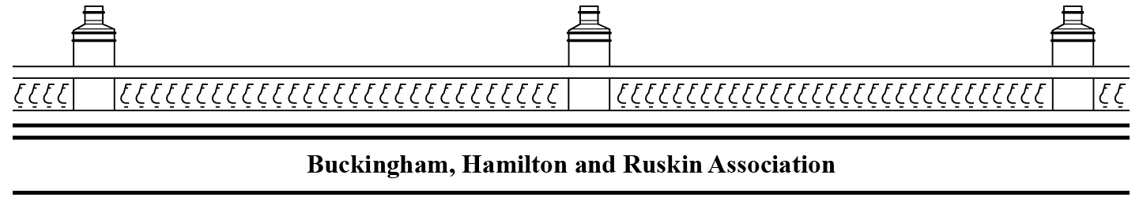

**Newsletter, October 2020**

**AGM: Zoom meeting**

**Tuesday 8 December 7.00pm**

**Halloween event, Sat. 31 October 5-7**

**The Viewpoint Hamilton Park Avenue**

The **AGM** will be held as a Zoom meeting. The annual accounts will be presented and other business discussed. An agenda and the link to join will be sent by email to members in due course. If you are not already a member and would like to join, contact us via email at the above address. Membership, currently £10 per household, can be paid into the bank account by electronic transfer:

Pay Buckingham, Hamilton Ruskin Association, sort code 82-64-08, a/c 80114396.

Please give your name and address as a reference, e.g. Goldman 19HD,

and send an email to say you have paid to help with records.



**The Viewpoint** The garden group has been working very hard and the results are plain to see. It is well used and we get a lot of compliments. We are going to have an informal event for children at Halloween, Saturday 31st October, 5--7. We will decorate the garden in the afternoon – candles, turnips, pumpkins and more. Anyone is welcome to help and to add to our display on Saturday mid-afternoon. If you want either sparklers or refreshments you will have to bring your own. It will not be supervised. If you come please observe social distancing.

**Trees** Due to Covid we have not had a visit from the council arboriculturist. However, Colin Miller has consulted a tree surgeon and on Hamilton Drive we will make a joint application to reduce the height of quite a few of the trees. If other areas, for instance the Terraces, are interested, email the committee and we can let you know how we are proceeding.

**Parking** Since lockdown parking restrictions have not been enforced very well. Corners tend to be parked up and access to Buckingham Street and Ruskin Lane can be a problem. Many of the signs have faded so much they are illegible. We will be asking for help from our councillors as well as the roads department with this.

**We hope to see you at the AGM.**

[**www.bhrassoc.org**](http://www.bhrassoc.org) **BHRAcommittee@gmail.com**