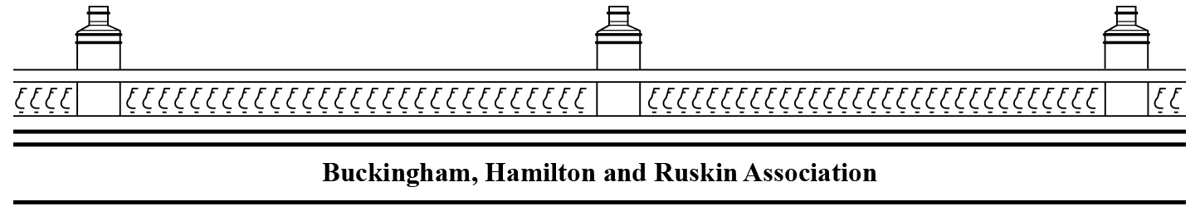

**The Viewpoint Community Garden**

**Saturday 15 August**

**10am Gardening Group meeting**

**2—4pm Association Party**

**At an EGM in February 2019 the association agreed to seek a lease of the Viewpoint to secure it for the use of the community. The committee has been working towards this and members have recently signed the lease.**

The management of the garden will be organised by the BHRA committee. Christine Mcguigan has agreed to act as co-ordinator.

There will be a meeting at 10 am in the gardens for anyone interested in helping.

In the afternoon from 2—4 there will be a garden party. If you come, bring your own glass/plate/mask and be prepared to move out of the garden onto the area we manage on the street to maintain social distancing.

Thanks are due to the many people who have volunteered their time in the garden, but especially to John Elder, who pursued the Council to get us the lease.

**Our aims are:**

* To improve the amenity of the area by reopening and looking after the garden for the community, particularly for residents without gardens.
* To provide a focal point for the community where people can meet casually and for community events.
* To protect the green environment and make it inviting and accessible to everyone.
* To develop the garden together, focusing on generating community spirit rather than horticultural excellence.
* To engage with the local community through regular updates on progress, activities and invitations to become involved.
* To protect the garden for the future by building a team of volunteers to maintain it and establishing and maintaining a record of planting etc.
* To have fun doing it.

**Contact us: bhrassoc.org**

**BHRAcommittee@gmail.com**